8th ARSO CONTINENTAL ESSAY COMPETITION
THE ROLE OF STANDARDIZATION IN PROMOTING ARTS, CULTURE AND HERITAGE- THE CREATIVE ECONOMY IN AFRICA
BY
ONWUKA PASCHALINE CHIAMAKA
5TH YEAR STUDENT OF THE DEPARTMENT OF MEDICINE AND SURGERY, UNIVERSITY OF NIGERIA, ITUKU-OZALLA, ENUGU STATE, NIGERIA.
CONTACT: +2349034923782
ROOM 209, NNAMDI AZIKIWE HALL, UNIVERSITY OF NIGERIA, OLD UNTH
ENUGU STATE, NIGERIA.
EMAIL ADDRESS: paschalineonwuka@gmail.com
WORD COUNT: 1,185 WORDS (EXCLUDING TITLE PAGE, REFEERENCES AND END NOTES)
MAY 2020

INTRODUCTION
A concerted effort to preserve our heritage is a vital link to our cultural legacy which is basically all of the things that make us who we are. Despite the fact that in recent years, various statistics and data on the cultural, arts and heritage sector of Africa, has underscored that they can be a powerful drive for development, with community wide social, economic and environmental impact, there has been no uniform or consistent data on the value of cultural and creative industries in Africa. The Creative Economy Report, 2008 suggested that Africa contributes less than 1% to world exports of creative goods but argued that this weak presence may signify not only limited support capacity on the continent but that the majority of creative and cultural production in Africa takes place in the informal sector and lacks standardization. This paper aims at discussing the role which standardization plays in promoting the creative economy of Africa.
BODY
The concept of the creative economy applies to the whole economy. It shifts the focus from a culture specific one to understanding the full economic contribution of culture, arts and heritage to the wider economy. According to UNCTAD 2015, the creative economy is an evolving concept which builds on the interplay between human creativity and ideas and intellectual property, knowledge and technology. The department of sports, arts and culture in South Africa refers to ‘Arts’ as the expression and application of creative skill and imagination. They also refer to ‘culture’ as belief and experiences acquired by a group of people from various generations and ‘Heritage’ as valued properties passed down from generations (DSAC South Africa, 2020).

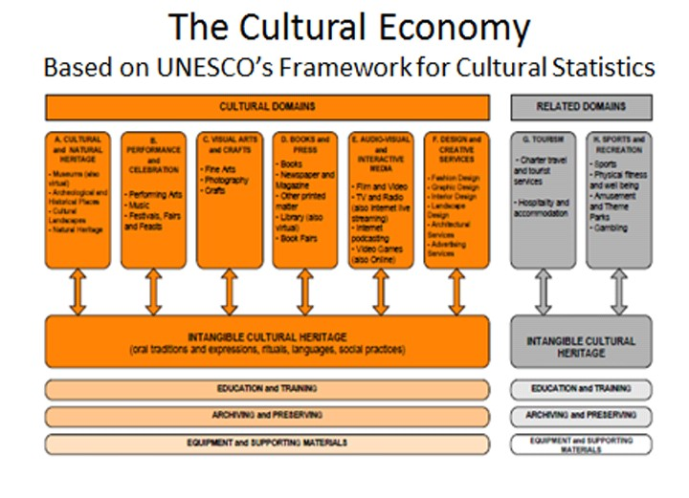
SOURCE: UNESCO, 2015
In as much as the global market size of creative goods has exponentially increased, thereby doubling in size from $208 billion in 2002 to $509 billion in 2015, Africa’s contribution to the creative economy is relatively small and hardly visible (UNCTAD, 2018). Because of this dilemma, the African Union Commission (AUC, 2021) identified some challenges that are facing the cultural industries in Africa. These issues border on lack of access to the global market, poor investment in education, playing catch-up to new technology, lack of standardization, inadequate infrastructures, poor financial leverage and uncompetitive and poor quality cultural products. Much of the commercial activity of the creative economy in Africa is unregulated and untaxed and therefore difficult to measure. There is also an ineffective partnership between the creative industries and the government with the core relationship remaining that between the artists and the ministries of arts and culture (UNESCO, 2015).
Though few African government departments of trade and industry and finance have developed a partnership with the creative industries, the major problem faced by most African countries is the poor implementation of instruments which contain the standards aimed at properly promoting their creative economy.
In the context of creative economy, standards refer to those guidelines or codes contained within series of international instruments adopted universally under the United Nations or within the framework of regional organizations such as the African Union to address the issues hampering proper utilization of the creative economy and how to ensure its promotion (ARSO, 2021). Various Policy Frameworks have been put in place by the, UNESCO, African Union (AU), Economic Community of West African States (ECOWAS), African Development Banks (AfDB), African Organization for Standardization (ARSO) to guide the development and promotion of creative economy in Africa. They are as follows:
- The UNESCO’s Framework for Cultural Statistics (FCS)- it is a comprehensive classification instrument for measuring the economic and social dimensions of culture based on the concept of the culture cycle model. (UNESCO, 2005).
- The Nairobi Plan of Action- this is an updated version of the Dakar Plan of Action on cultural industries, which was adopted in 1992 Organization of African Unity (OAU) heads of state and Government. The primary goal of this plan is to tap into the vast economic and social potential of African cultural and creative resources in the African global development process, and to bring about tangible improvement in living standards of African artist and creators. (AU,2005).
- The Charter for African Cultural Renaissance, 2006- It was adopted by Summit of the Heads of State AU 6th ordinary session of the Assemble in Khartoum on 24th January 2006.
- AfDB Creative Industries: Fashionomics, 2016-it is active in Nigeria, Cote d’ivoire, Nigeria, South Africa and Kenya. It is a Pan-African programme which aims at strengthening the value chain of the fashion sector by investing in African textiles.
- RECs Initiatives-ECOWAS – ECOWAS adopted a regional action plan for the return of African Cultural Artefacts to their countries of origin in 2019. (ECOWAS, 2019).
- United Nations Sustainable Development Goals, 2030- The link between culture and development forms part of the 2030 Agenda and is reflected in a number of SDGs.
- ARSO- The fundamental role of this crucial organization is to develop and harmonize African standards and conformity assessment procedures for the purpose enhancing Africa’s internal trading capacity, increase product and service competitiveness globally and to uplift the welfare of the African communities. (ARSO, 2021)


SOURCE: ARSO, 2021

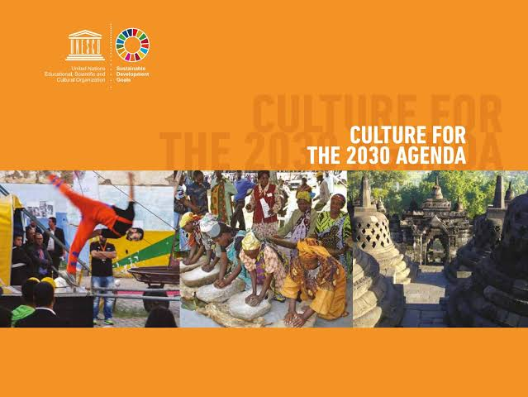
SOURCE: UNESCO, 2018

These standards help in the creation of durable solutions to the problems plaguing the creative economy in Africa. They help in identifying and minimizing risks, promoting successful commercialization of new products, consumer protection, enabling variety reduction and ensuring the compatibility of products and economies of scale. The Made in Africa Qualification/Standard which was initiated by ARSO and AU in 2020 has helped in fostering industrialization, productive capacities, promoting export diversification, protecting intellectual property and intra-Africa trades for brands and products made in African continent by creating global value-chains. (Creative Economy Outlook, 2020).
In Segou, Mali, their creative economy has been thriving through an entrepreneurial model called Maaya Entrepreneurship. This model was nurtured through the festival ‘sur le Niger’ and it has managed to stimulate development in Segou by ensuring supply of all goods and services by the local population (Godelieve Spaas, 2012). The Pamberi Trusts’ Book Café in Zimbabwe is an example of an attempt to promote the arts business through standardization. It is an NGO that provides a structure to enable performing, literary and visual artists to operate and grow. It has spawned a lot of governmental projects to achieve this vision (African Creative Economy Conference, 2012). Africa’s first and largest urban culture festival was Architecture oriented which held in September 2010 in Johannesburg. The aim was to expose the complexity of Johannesburg’s urban cultures and to intensify awareness of the roles that architecture can play (Andrew Boraine, 2010). All these milestones were achieved due to the efforts put by these nations in implementing the already set standards thereby promoting their respective creative economies.
CONCLUSION
As William Clinton pointed out, the arts have been an integral and vibrant part of a nation’s cultural heritage. The year 2021 was declared by the African Union as The AU year of Arts, Culture and Heritage and adopted the theme ‘Art, Culture and Heritage: Levers for Building the Africa We Want. This solidifies the importance of properly utilizing our creative economy as a means to broaden the revenue of the African economy.
REFERENCES
1. African Creative Economy Conference, 2012: "Renegotiating the Approach to Cultural Development: The Creative Business Model of Pamberi Trust’s Book Café, Florence Mukanga-Majachani"
2. African Union, 2005: "Dakar and Nairobi Plan of Action on Cultural Industries". http://ocpa.irmo.hr › docsPD Web results
3. AfDB, 2016: "AfDB - Creative Industries: Fashionomics". https://www.afdb.org/en/news-and-events/afdb-leads-initiative-to-boost-potential-of-africas-creative-sector-16157 NAIROBI PLAN OF ACTION FOR CULTURAL INDUSTRIES IN ...
4. Andrew Boraine, 2010. http://www.andrewboraine.com/2010/05/whos-afraid-of-our-south-african-urban-culture/
5. AUC, 2012: "The African Continental Free Trade Area Agreement and the related Annexes" https://au.int/en/theme/2021/arts-culture-and-heritage.
6. ARSO, 2021. http://www.tbs.go.tz › filesPDF concept note 2020 2021 african day of standardisation theme - TBS
7. Charter for African Culture Renaissance, 2006. http://www.africa-union.org/root/au/Documents/Treaties/text/Charter%20-%20African%20Cultural%20Renaissance_EN.pdf
8. Creative Economic Outlook, 2020. https://unctad.org/webflyer/creative-economy-outlook-trends-international-trade-creative-industries
9. DSAC South Africa, 2020. https://www.srsa.gov.za/media/department-sport-arts-and-culture-launch-africa-month-2021
10. ECOWAS, 2019. https://www.ecowas.int/ecowas-member-states-discuss-the-return-of-african-cultural-property-to-their-countries-of-origin/
11. Godelieve Spaas, 2012: "Maaya Entrepreneurship: the entrepreneurial model for the Festival sur le Niger", La Sahélienne Edition, 2012, pg 56
12. The Creative Economy Report, 2008: “Culture: a driver and an enabler of sustainable development"
13. UNESCO, 2005: "UNESCO Convention on the Protection and Promotion of the Diversity of Cultural Expressions", 2005.
14. UNESCO, 2015. http://www.unesco.org/new/en/culture/themes/cultural-diversity/diversity-of-culturalexpressions/programmes/capacity-building-in-africa/
15. UNCTAD, 2015: "Intra-African Trade: Unlocking Private Sector Dynamism" https://unctad.org/webflyer/trade-and-development-report-2015
16. UNTCAD, 2018: "Creative Economy Outlook: Trends in international trade in creative industries" - Country Profiles, 2002–2015, 2005–2014.

